Chapter 2 Moving heat around

Chapter test answers Total marks 47

Section A

Question 1

A. Insulation is not a method of heat transfer. (1 mark)

Question 2

B. Heat is transferred by contact between the surface of the iron and clothes. (1 mark)

Question 3

D. The flame heats the pan by radiation, heat is transferred through the pot by conduction, and heat rises through the water to the surface via convection. (1 mark)

Question 4

C. Heat transfer through molecular or atomic collisions without overall transfer of the substance itself. (1 mark)

Question 5

C. Reflective coating reduces the emission of radiation from the inner wall. (1 mark)

Question 6

C. Hot air expands and rises to the ceiling, while cooler air sinks to the floor. The ceiling fans mix the hot and cool air, making the whole room warm. (1 mark)

Question 7

C.

 (1 mark)

Question 8

C.

(1 mark)

Note: light and sound are both useful for a television’s operation.

Question 9

B. When work is done *on* a system, energy is added so there is an increase to its internal energy. When work is done *by* a system, energy is removed so its internal energy decreases. (1 mark)

Question 10

D. Both light energy and thermal energy is emitted from the torch. (1 mark)

Section B

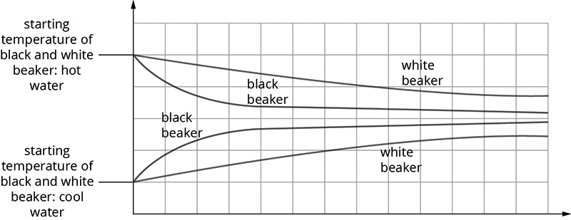Question 11

(4 marks)

Question 12

No, convection can only occur in liquids and gases. (1 mark)

Convection requires atoms and molecules to move, and in solids they are held in place. (1 mark)

Question 13

Metals are good conductors of heat. (1 mark)

Heat moves easily from your warm hand to the metal and so the metal feels colder. (1 mark)

Wood is a poor conductor of heat and only a small amount of heat is transferred from your hand to the wood, so that your hand does not sense it is touching something cooler. (1 mark)

Question 14

They are black to increase the absorption of radiation. Matte black surfaces absorb radiant energy more than shiny white surfaces. (1 mark)

Question 15

efficiency (%) =  (1 mark)

 (1 mark)

= 9 MJ (1 mark)

Question 16

Double-glazed windows slow down heat transfer by conduction—as air is a poor conductor of heat, the narrow air gap acts as an insulator. (2 marks)

Double-glazed windows slows down heat transfer by convection—as the air gap is narrow, convection currents are not easily established. (2 marks)

Question 17

a efficiency (%) =  (1 mark)

= 

= 45% (1 mark)

**b** heat (thermal) energy and sound energy (1 mark)

Question 18

a 150 J (1 mark)

b electrical energy into kinetic energy (1 mark)

c efficiency (%) =  = 25% (2 marks)

Question 19

Hot water is less dense than the cold water around the ice cube, and so it remains at top of the test tube. (1 mark)

There is no heat transfer by convection. (1 mark)

Any heat transfer is by conduction, and heat conduction through liquids and gases is poor. (1 mark)

The ice remains unmelted, even though the water is boiling at the top of the test tube. (1 mark)

Section C

Question 20

Answers will vary. Examples include: double-glazed windows, roof insulation, wall insulation, floor insulation, heavy curtains, draught-proof doors.

1 mark for each improvement (3 marks)

3 × 2 marks for identifying heat transfer responsible and how heat transfer is minimised. (6 marks)